[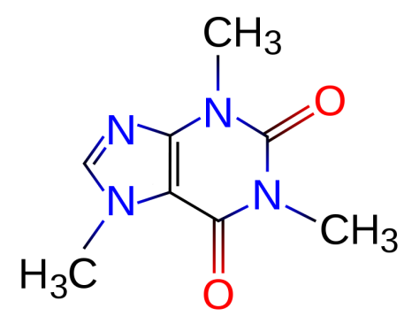](http://upload.wikimedia.org/wikipedia/commons/d/d8/Caffeine.svg)

samples

1. Caffeine

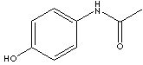

1. Tylenol acetaminophen

[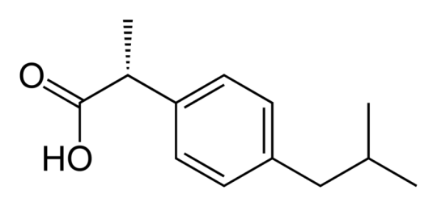](http://upload.wikimedia.org/wikipedia/commons/f/f8/R-ibuprofen-B-2D-skeletal.png)

1. Advil, Motrin ibuprofen

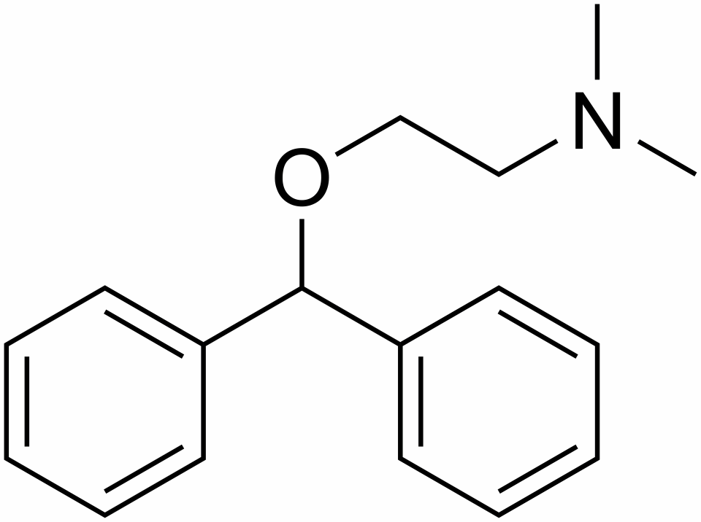

1. Benadryl **Diphenylhydramine hydrochloride**

[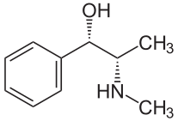](http://upload.wikimedia.org/wikipedia/commons/e/e5/(+)-Pseudoephedrin.svg)

1. **Sudafed pseudoepinephrin**

[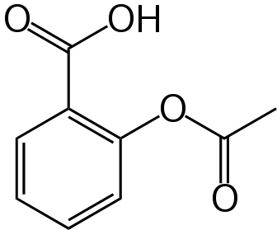](http://upload.wikimedia.org/wikipedia/commons/6/67/Aspirin-skeletal.svg)

6) **Aspirin acetylsalicylic acid**

[](http://upload.wikimedia.org/wikipedia/commons/d/d8/Caffeine.svg)

**Unknowns**

**1)No Doz caffeine**

1,3,7-trimethyl- 1*H*-purine- 2,6(3*H*,7*H*)-dione

* **Acute** caffeine poisoning gives early symptoms of anorexia, tremor, and restlessness. Followed by nausea, vomiting, tachycardia, and confusion. Serious intoxication may cause delirium, seizures, supraventricular and ventricular tachyarrhythmias, hypokalemia, and hyperglycemia.
* **Chronic** high-dose caffeine intake can lead to nervousness, irritability, anxiety, tremulousness, muscle twitching, insomnia, palpitations and hyperreflexia. For blood testing, cross-reaction with theophylline assays will detect toxic amounts. (Method IA) Blood concentration of 1-10 mg/L is normal in coffee drinkers, while 80 mg/L has been associated with death.

### Symptoms

* Abdominal pain
* Appetite loss
* [Coma](http://health.nytimes.com/health/guides/symptoms/consciousness-decreased/overview.html)
* [Convulsions](http://health.nytimes.com/health/guides/symptoms/seizures/overview.html)
* [Diarrhea](http://health.nytimes.com/health/guides/symptoms/diarrhea/overview.html)
* Irritability
* [Jaundice](http://health.nytimes.com/health/guides/symptoms/jaundice-yellow-skin/overview.html)
* [Nausea](http://health.nytimes.com/health/guides/symptoms/nausea-and-vomiting/overview.html)
* [Sweating](http://health.nytimes.com/health/guides/symptoms/sweating/overview.html)
* [Upset stomach](http://health.nytimes.com/health/guides/symptoms/nausea-and-vomiting/overview.html)

Vomiting

**2)Tylenol acetaminophen**



4_-Hydroxyacetanilide

Note: Symptoms may not occur until 12 or more hours after the acetaminophen was swallowed

**3)Advil ibbuprofen**

[](http://upload.wikimedia.org/wikipedia/commons/f/f8/R-ibuprofen-B-2D-skeletal.png)

**4)Motrin**

[**2-[4-(2-methylpropyl)phenyl]propanoic acid**](http://www.chemindustry.com/chemicals/099764.html)

unsteadiness, blurred vision, ringing in the ears, gastrointestinal, nausea plus vomiting, diarrhea, stomach pain, probable loss of blood in intestinal areas or stomach or both, headache, agitation, drowsiness, incoherence and confusion

**5)Benadryl Diphenylhydramine hydrochloride**



2-(diphenylmethoxy)-*N,N*-dimethylethanamine

**(allergies, antihistamine)**

This leads to profound drowsiness as a very common side-effect. Diphenhydramine has also been used as an [anxiolytic](http://en.wikipedia.org/wiki/Anxiolytic) because of these sedating side effects. However, other side effects include possibilities of motor impairment ([ataxia](http://en.wikipedia.org/wiki/Ataxia)), dry mouth and throat, flushed skin, rapid or irregular heartbeat ([tachycardia](http://en.wikipedia.org/wiki/Tachycardia)), blurred vision at nearpoint owing to lack of accommodation ([cycloplegia](http://en.wikipedia.org/wiki/Cycloplegia)), abnormal sensitivity to bright light ([photophobia](http://en.wikipedia.org/wiki/Photophobia)), pupil dilation ([mydriasis](http://en.wikipedia.org/wiki/Mydriasis)), [urinary retention](http://en.wikipedia.org/wiki/Urinary_retention), constipation, difficulty concentrating, short-term memory loss, visual disturbances, hallucinations, irregular breathing, dizziness, irritability, itchy skin, confusion, decreased body temperature (generally in the hands and/or feet), [erectile dysfunction](http://en.wikipedia.org/wiki/Erectile_dysfunction)

**6)Aspirin acetylsalicylic acid**

[](http://upload.wikimedia.org/wikipedia/commons/6/67/Aspirin-skeletal.svg)

hives, swelling, and headache…stomach ulcers and

internal bleeding

**7) Sudafed pseudoepinephrin**

(R*,R*)-2-methylamino-1-phenylpropan-1-ol

[](http://upload.wikimedia.org/wikipedia/commons/e/e5/(+)-Pseudoephedrin.svg)

sleeplessness, nervousness, excitability, dizziness and anxiety. Infrequent ADRs include: [tachycardia](http://en.wikipedia.org/wiki/Tachycardia) and/or [palpitations](http://en.wikipedia.org/wiki/Palpitation). Rarely, pseudoephedrine therapy may be associated with [hallucinations](http://en.wikipedia.org/wiki/Hallucination), [arrhythmias](http://en.wikipedia.org/wiki/Arrhythmia), [hypertension](http://en.wikipedia.org/wiki/Hypertension), seizures and [ischemic colitis](http://en.wikipedia.org/wiki/Ischemic_colitis);[[10]](http://en.wikipedia.org/wiki/Pseudoephedrine#cite_note-Rossi-9) as well as severe skin reactions known as recurrent pseudo-scarlatina, systemic contact dermatitis

**Unknowns**

1. Ibuprofen (advil) S form is active…major component of advil

[**2-[4-(2-methylpropyl)phenyl]propanoic acid**](http://www.chemindustry.com/chemicals/099764.html)**,** [](http://upload.wikimedia.org/wikipedia/commons/f/f8/R-ibuprofen-B-2D-skeletal.png)

|  |  |  |
| --- | --- | --- |
| **IBUPROFEN** | | |
| PRODUCT IDENTIFICATION | | |
| CAS NO. | 15687-27-1 | IBUPROFEN |
| EINECS NO. | 239-784-6 |
| FORMULA | (CH3)2CHCH2C6H4CH(CH3)COOH |
| MOL WT. | 206.29 |
| H.S. CODE | 2916.39 |
| TOXICITY | ORL-RAT LD50:636 MG/KG |
| SYNONYMS | 2-(4-isobutylphenyl)propionic Acid; Apsifen; Apsifen-F; | |
| Alpha-Methyl-4-(2-methylpropyl)benzeneacetic acid; Acide (Isobutyl-4 Phenyl)-2 Propionique (French); Ibuprocin; para-Isobutylhydratropic acid; (+/-)-2-(p-Isobutyl phenyl)propionic acid; (+)-2-(4-Isobutyl phenyl)propionic acid; 4-Isobutyl- alpha-methylphenylacetic acid; Ibufen; Ibuprin; Alpha-methyl-4-(2-Methylpropyl)- Benzeneacetic Acid; | | |
| DERIVATION |  | |
| CLASSIFICATION |  | |
| PHYSICAL AND CHEMICAL PROPERTIES | | |
| PHYSICAL STATE | white crystalline powder | |
| MELTING POINT | 75 - 78 | |
| BOILING POINT |  | |
| SPECIFIC GRAVITY |  | |
| SOLUBILITY IN WATER | Practically insoluble | |
| pH |  | |
| VAPOR DENSITY |  | |
| AUTOIGNITION |  | |
| NFPA RATINGS |  | |
| REFRACTIVE INDEX |  | |
| FLASH POINT |  | |
| STABILITY | Stable under ordinary conditions | |
| APPLICATIONS | | |
| Ibuprofen is a drug belong to a class of NSAID (nonsteroidal anti-inflammatory drug acts by inhibiting isoforms of cyclo-oxygenase 1 and 2. It has an activity to treat inflammatory  rheumatoid diseases and relieve acute pain. It is effective against period pains, pain after surgery, and fever. | | |

**Thermodynamic evaluation of ibuprofen solubility in aqueous and non-aqueous cosolvent systems**

by *Khalifeh, Ismail Mahmoud*, Ph.D., **Purdue University**, 2000, 234 pages; AAT 3033111

**Abstract (Summary)**

The purpose of this research was to investigate the mechanism of solubilization of a model drug, ibuprofen, in cosolvent-water mixtures by applying enthalpy-entropy compensation analysis. The solubility of ibuprofen in pure solvents decreased in the following order: DMSO > methanol > ethanol > isopropanol > n-propanol > PEG-200 > PG > water. The addition of ibuprofen to n-propanol-water mixtures, isopropanol-water mixtures and DMSO-water mixtures resulted in phase-separation. The increase in ibuprofen solubility in the binary cosolvent-water mixtures decreased in the following order: isopropanol-water mixtures > n-propanol-water mixtures > ethanol-water mixtures > methanol-water mixtures > PEG-water mixtures > PG-water mixtures. The solubility of ibuprofen in PG-ethanol mixtures decreased linearly as the amount of PG in the solvent mixture increased. The enthalpy of solution of ibuprofen in the solvent mixtures varied nonlinearly with solvent composition. In aqueous systems, the enthalpy of solution increased to a maximum and then decreased as the cosolvent mole fraction increased. The entropy of solution of ibuprofen showed similar trend as that of heat of solution. The maximum in enthalpy and entropy of solution appeared at the same cosolvent mole fraction. The free energy evaluated at the harmonic mean of experimental temperature decreased as the cosolvent mole fraction increased. At low cosolvent mole fraction, up to the maximum in enthalpy and entropy versus composition curves, the solubility of ibuprofen was entropy driven while beyond the peaks, the solubility of ibuprofen was enthalpy driven. For PG-ethanol system, a linear increase in both enthalpy and entropy of solution as a function of PG mole fraction was found. The mechanism of decrease in ibuprofen solubility was due to unfavorable increase in enthalpy of solution. Enthalpy-entropy compensation analysis, showed that a nonlinear compensation existed between enthalpy and entropy due to variation in solvent composition and not to propagation of experimental errors. The change in the slope of ΔH versus ΔG hm curves for aqueous systems indicated that two different mechanisms contribute to the solubility of ibuprofen depending on the nature of the solvent system. However, for PG-ethanol mixtures, no peak was observed in the ΔH versus ΔG hm plot suggesting that one mechanism is responsible for the decrease in ibuprofen solubility as the amount of PG was increased.



**Indexing (document details)**

|  |  |
| --- | --- |
| **Advisor:** | Kildsig, Dane O. |
| **School:** | Purdue University |
| **School Location:** | United States -- Indiana |
| **Keyword(s):** | Ibuprofen, Solubility, Cosolvent |
| **Source:** | DAI-B 62/11, p. 5057, May 2002 |
| **Source type:** | Dissertation |
| **Subjects:** | Pharmaceuticals |
| **Publication Number:** | AAT 3033111 |
| **ISBN:** | 0493460659 |
| **Document URL:** | http://proquest.umi.com/pqdlink?did=726066411&Fmt=7&clientId =79356&RQT=309&VName=PQD |

1. Caffeine (No Doz)

[](http://upload.wikimedia.org/wikipedia/commons/d/d8/Caffeine.svg)

1,3,7-trimethyl- 1*H*-purine- 2,6(3*H*,7*H*)-dione

2.17 g/100 mL water at 25 C

#### **Soluble** in water (1 in 68), boiling water (1 in 1), alcohol (1 in 40), chloroform (1 in 7), ether (1 in 400), or benzene; its solubility in water is much increased by the addition of sodium benzoate or salicylate

[http://bits.wikimedia.org/skins-1.5/common/images/magnify-clip.png](http://en.wikipedia.org/wiki/File:Main_symptoms_of_Caffeine_overdose.png) Caffeine intoxication

Main symptoms of caffeine intoxication.[[68]](http://en.wikipedia.org/wiki/Caffeine#cite_note-Medline-67)

An acute overdose of caffeine, usually in excess of about 300 milligrams, dependent on body weight and level of caffeine tolerance, can result in a state of central nervous system over-stimulation called *caffeine intoxication* ([DSM-IV](http://en.wikipedia.org/wiki/DSM-IV) 305.90),[[91]](http://en.wikipedia.org/wiki/Caffeine#cite_note-DSM-IV-90) or colloquially the "caffeine jitters". The symptoms of caffeine intoxication are not unlike overdoses of other [stimulants](http://en.wikipedia.org/wiki/Stimulants). It may include restlessness, [nervousness](http://en.wikipedia.org/wiki/Nervousness), excitement, insomnia, flushing of the face, [increased urination](http://en.wikipedia.org/wiki/Diuresis), [gastrointestinal](http://en.wikipedia.org/wiki/Gastrointestinal_tract) disturbance, [muscle twitching](http://en.wikipedia.org/wiki/Fasciculation), a rambling flow of thought and speech, irritability, [irregular](http://en.wikipedia.org/wiki/Cardiac_arrhythmia) or [rapid heart beat](http://en.wikipedia.org/wiki/Tachycardia), and [psychomotor agitation](http://en.wikipedia.org/wiki/Psychomotor_agitation).[[89]](http://en.wikipedia.org/wiki/Caffeine#cite_note-EofMD-88) In cases of much larger overdoses, [mania](http://en.wikipedia.org/wiki/Mania), [depression](http://en.wikipedia.org/wiki/Depression_(mood)), lapses in judgment, [disorientation](http://en.wikipedia.org/wiki/Disorientation), [disinhibition](http://en.wikipedia.org/wiki/Disinhibition), [delusions](http://en.wikipedia.org/wiki/Delusions), [hallucinations](http://en.wikipedia.org/wiki/Hallucinations), and [psychosis](http://en.wikipedia.org/wiki/Psychosis) may occur, and [rhabdomyolysis](http://en.wikipedia.org/wiki/Rhabdomyolysis) (breakdown of skeletal muscle tissue) can be provoked.[[92]](http://en.wikipedia.org/wiki/Caffeine#cite_note-91)[[93]](http://en.wikipedia.org/wiki/Caffeine#cite_note-92)

1. Acetaminophen (Tylenol)

**Chemical Names**

*N*-(4-Hydroxyphenyl)acetamide

4_-Hydroxyacetanilide

**Other Names**

Paracetamol, Tempra, Tylenol

**Form Molecular Formula MW CAS**

Acetaminophen C8H9NO2 151.2 103-90-2

**Appearance**

Acetaminophen occurs as a white crystalline powder with a slightly bitter taste.

**Solubility**

Acetaminophen is soluble in boiling water and freely soluble in alcohol.

|  |  |  |
| --- | --- | --- |
| **ACETAMINOPHEN** | | |
| PRODUCT IDENTIFICATION | | |
| CAS NO. | 103-90-2 | ACETAMINOPHEN |
| EINECS NO. | 203-157-5 |
| FORMULA | CH3CONHC6H4OH |
| MOL WT. | 151.17 |
| H.S. CODE | 2924.29 |
| TOXICITY | Oral rat 2404 mg/kg |
| SYNONYMS | 4'-hydroxyacetanilide; Tylenol; Paracetamol; Paracetamolo; | |
| Paracetamole; P-acetamido-Phenol; 4'-hydroxyacetanilide; n-(p- Hydroxyphenyl)-Acetamide; N-(4-hydroxyphenyl)-Acetamide; P-acetamidophenol; 4-Acetamidophenol; Acetaminofen; Acetaminophen; P- Acetaminophenol; N-acetyl-p-aminophenol; P-Acetylamino Phenol; P-hydroxyacetanilide; Paracetamol; 4-hydroxy Acetanilide; 4-hydroxyanilid Kyseliny Octove; N-(4-hydroxyphenyl) Acetamide; | | |
| DERIVATION | p-aminophenol, acetic anhydride | |
| CLASSIFICATION |  | |
| PHYSICAL AND CHEMICAL PROPERTIES | | |
| PHYSICAL STATE | white crystalline powder | |
| MELTING POINT | 169 - 172 C | |
| BOILING POINT |  | |
| SPECIFIC GRAVITY | 1.293 | |
| SOLUBILITY IN WATER | miscible | |
| pH | 5.5 - 6.5 | |
| VAPOR DENSITY |  | |
| AUTOIGNITION |  | |
| NFPA RATINGS | Health: 0 Flammability: 1 Reactivity: 0 | |
| REFRACTIVE INDEX |  | |
| FLASH POINT |  | |
| STABILITY | Stable under ordinary conditions | |

1. Allergy tablets (antihistamine) diphenylhydramine

2-(diphenylmethoxy)-*N,N*-dimethylethanamine



|  |  |
| --- | --- |
| [CAS number](http://en.wikipedia.org/wiki/CAS_registry_number) | [58-73-1](http://www.nlm.nih.gov/cgi/mesh/2009/MB_cgi?term=58-73-1&rn=1) |

Water solubility 3.06 mg/mL water at 37 oC (Beilstein)

Description **Diphenhydramine** **Hydrochloride** occurs as

white crystals or crystalline powder. It is odorless, and has a

bitter taste, followed by a sensation of numbness on the ton-

gue.

It is very soluble in methanol and in acetic acid (100), free-

ly soluble in water and in ethanol (95), sparingly soluble in

acetic anhydride, and practically insoluble in diethyl ether.

It is gradually affected by light.